***Preliminary Design Review

Electrical Power System with MPPT Solar Input

Submitted to:

Professor J. Kruth

Engineering Programs Manager

Space Science Center

Morehead State University

Submitted by:

Elijah K. Gibbs

Lead Engineer

Space Science & Engineering

November 24, 2023

Revision History

|  |  |  |  |
| --- | --- | --- | --- |
| REV NO. | RELEASE DATE | BRIEF DESCRIPTION/REASON FOR CHANGE | Effective Pages |
| #.# | MM/DD/YYYY | Changes from last version |  |
| 1.0 | 10/17/2023 | Created Skeleton for PDR | 1-10 |
| 1.1 | 11/10/2023 | Added in subsystems elements/added software implementation | 2-10 |
| 1.2 | 11/11/2023 | Added MPPT, BCR, and Battery section and made changes to the Software page | 4-7 |
| 1.3 | 11/12/2023 | Added Regulated Output, microcontroller, schedule, and budget section | 8-11 |
| 1.4 | 11/13/2023 |  |  |
|  |  |  |  |
|  |  |  |  |
|  |  |  |  |
|  |  |  |  |
|  |  |  |  |
|  |  |  |  |
|  |  |  |  |
|  |  |  |  |
|  |  |  |  |
|  |  |  |  |
|  |  |  |  |
|  |  |  |  |
|  |  |  |  |
|  |  |  |  |
|  |  |  |  |
|  |  |  |  |
|  |  |  |  |
|  |  |  |  |
|  |  |  |  |
|  |  |  |  |
|  |  |  |  |
|  |  |  |  |
|  |  |  |  |
|  |  |  |  |
|  |  |  |  |
|  |  |  |  |
|  |  |  |  |
|  |  |  |  |
|  |  |  |  |
|  |  |  |  |
|  |  |  |  |
|  |  |  |  |
|  |  |  |  |
|  |  |  |  |

Table of Contents

Introduction: 4

Project Statement: 4

Relevant Technical Issues/Risks: 4

Project Requirements: 5

Subsystem Design: 5

Tradeoffs: 5

Software: 6

Maximum Power Point Tracking: 7

Battery Charge Regulator: 8

Batteries: 9

Regulated Lines/Output: 10

Microcontroller: 11

PCB Layout: 11

Fusion Model: 13

Schedule/Current Status: 14

Budget: 15

Bibliography: 17

Table of Figures

Figure 1: System Level Design 5

[Figure 2: Software Flow Chart 6](https://moreheadstateedu28844-my.sharepoint.com/personal/m1206707_moreheadstate_edu/Documents/Fall_Semester_2023/SSE%20498%20Senior%20Design%20Project%20I/Project%20Documents/GibbsE%20PDR%2011-14-2023.docx#_Toc152577198)

[Figure 3: MPPT Schematic 7](https://moreheadstateedu28844-my.sharepoint.com/personal/m1206707_moreheadstate_edu/Documents/Fall_Semester_2023/SSE%20498%20Senior%20Design%20Project%20I/Project%20Documents/GibbsE%20PDR%2011-14-2023.docx#_Toc152577199)

[Figure 4: Battery Charger Regulator Schematic 8](https://moreheadstateedu28844-my.sharepoint.com/personal/m1206707_moreheadstate_edu/Documents/Fall_Semester_2023/SSE%20498%20Senior%20Design%20Project%20I/Project%20Documents/GibbsE%20PDR%2011-14-2023.docx#_Toc152577200)

[Figure 5:Battery Layout Schematic 9](https://moreheadstateedu28844-my.sharepoint.com/personal/m1206707_moreheadstate_edu/Documents/Fall_Semester_2023/SSE%20498%20Senior%20Design%20Project%20I/Project%20Documents/GibbsE%20PDR%2011-14-2023.docx#_Toc152577201)

[Figure 6: Output Regulated Lines Schematic 10](https://moreheadstateedu28844-my.sharepoint.com/personal/m1206707_moreheadstate_edu/Documents/Fall_Semester_2023/SSE%20498%20Senior%20Design%20Project%20I/Project%20Documents/GibbsE%20PDR%2011-14-2023.docx#_Toc152577202)

[Figure 7: Single Regulated Output 10](https://moreheadstateedu28844-my.sharepoint.com/personal/m1206707_moreheadstate_edu/Documents/Fall_Semester_2023/SSE%20498%20Senior%20Design%20Project%20I/Project%20Documents/GibbsE%20PDR%2011-14-2023.docx#_Toc152577203)

[Figure 8: Microcontroller Layout 11](https://moreheadstateedu28844-my.sharepoint.com/personal/m1206707_moreheadstate_edu/Documents/Fall_Semester_2023/SSE%20498%20Senior%20Design%20Project%20I/Project%20Documents/GibbsE%20PDR%2011-14-2023.docx#_Toc152577204)

[Figure 9: Main Board Layout 12](https://moreheadstateedu28844-my.sharepoint.com/personal/m1206707_moreheadstate_edu/Documents/Fall_Semester_2023/SSE%20498%20Senior%20Design%20Project%20I/Project%20Documents/GibbsE%20PDR%2011-14-2023.docx#_Toc152577205)

[Figure 10: EPS Main Board 13](https://moreheadstateedu28844-my.sharepoint.com/personal/m1206707_moreheadstate_edu/Documents/Fall_Semester_2023/SSE%20498%20Senior%20Design%20Project%20I/Project%20Documents/GibbsE%20PDR%2011-14-2023.docx#_Toc152577206)

[Figure 11: Battery Board 13](https://moreheadstateedu28844-my.sharepoint.com/personal/m1206707_moreheadstate_edu/Documents/Fall_Semester_2023/SSE%20498%20Senior%20Design%20Project%20I/Project%20Documents/GibbsE%20PDR%2011-14-2023.docx#_Toc152577207)

[Figure 12: Gannt Chart 14](https://moreheadstateedu28844-my.sharepoint.com/personal/m1206707_moreheadstate_edu/Documents/Fall_Semester_2023/SSE%20498%20Senior%20Design%20Project%20I/Project%20Documents/GibbsE%20PDR%2011-14-2023.docx#_Toc152577208)

Table of Tables

Table 1: Table of Risks 4

[Table 2: Hourly Wages 15](https://moreheadstateedu28844-my.sharepoint.com/personal/m1206707_moreheadstate_edu/Documents/Fall_Semester_2023/SSE%20498%20Senior%20Design%20Project%20I/Project%20Documents/GibbsE%20PDR%2011-14-2023.docx#_Toc152577210)

[Table 3: Materials Cost 15](https://moreheadstateedu28844-my.sharepoint.com/personal/m1206707_moreheadstate_edu/Documents/Fall_Semester_2023/SSE%20498%20Senior%20Design%20Project%20I/Project%20Documents/GibbsE%20PDR%2011-14-2023.docx#_Toc152577211)

[Table 4: Indirect Costs 16](https://moreheadstateedu28844-my.sharepoint.com/personal/m1206707_moreheadstate_edu/Documents/Fall_Semester_2023/SSE%20498%20Senior%20Design%20Project%20I/Project%20Documents/GibbsE%20PDR%2011-14-2023.docx#_Toc152577212)

Introduction:

Project Statement:

The project that has been chosen to be undertaken is the designing and implementation of a prototype EPS. The goal of this EPS is to provide power for a satellite mission in LEO orbit. It will use MPPT to allow for the maximum amount of power to be gathered during the rapidly changing environment common to LEO orbits. The EPS will provide the satellite with two regulated power buses. These power buses encompass a 5V line, a 3.3V line, and a 12V line. There will be basic sensor functionality to monitor the EPS and ensure the EPS operates in the expected ranges. This sensor functionality will be supported by a microcontroller. This microcontroller will also be utilized to control sections of the EPS and ensure functionality.

Relevant Technical Issues/Risks:

This project itself presents many unique challenges that will need to be addressed. These Technical challenges are:

* Providing enough power for eclipse time.
* Ensuring that heat of parts can be distributed properly
* Ensuring that parts are protected from overvoltage overcurrent events.
* Ensuring that batteries can be charge in the given available time

Risks are something that must also be considered when looking at the project. For this project they have been split into two main categories. These are programmatic risks and technical risks. These programmatic risks may be considered anything that will slow the project down or delay its implementation. Current considerations for this are the cost of parts and lead time for said parts. Meaning obviously parts are to be kept as low cost as viable without compromising the quality of the final project. Following that parts must also be selected if and only if they have lead times that can be considered responsible for what is available. Overall parts with lead times over 4 weeks are to be avoided and anything smaller is to be considered amongst the other available parts.

|  |  |
| --- | --- |
| Programmatic: | Technical: |
| Part Costs | Heat distribution |
| Lead Times | Current/Voltage limits |
|  | Generating Electric/Magnetic Fields |
|  | Electrostatic Shock |

Table : Table of Risks

Project Requirements:

An EPS that will be built that shall:

* Generate power from solar array
* Utilizes a MPPT structure to allow for maximum power to be gathered
* Regulate power going in and out of the batteries
* Take power from batteries and regulates it to a 3.3V regulated line, 5V regulated line and 12V regulated line.
* Ensure power is distributable to multiple other systems
* Have onboard microcontroller to control and monitor EPS with sensors

Subsystem Design:

Figure : System Level Design

Tradeoffs:

To ensure that the satellite will be provided power during eclipse the battery will be built to have a minimum of 42Whrs and will be built so that in the future it can be expanded upon to allow for mission that may require the use of higher power devices. To ensure that the heat of the devices is properly managed it will be ensured that the trace widths of the PCB will be large enough to allow for proper dissipation of this heat through conduction, in addition to this there will be sufficient ground pads available for parts that will produce excessive heat. Such as FETs and other voltage regulators. To ensure that parts are protected from overvoltage voltage clamps will be placed in strategic areas to ensure that voltages do not exceed the capability of the supplied parts. Overcurrent protection will include fuses in strategic areas that will ensure that if the current exceeds a safe limit that the parts around them will not be blown up. These fuses will need to be resettable so PLC fuses can be used in these instances to ensure that when the fuse blows the satellite is not taken offline. To ensure that the batteries can charge in the available time a MPPT power structure will be utilized to ensure that the max amount of power generated from the solar panels.

Software:

In the realm of software implementation, the current approach entails the utilization of MicroPython on the advanced SEEED STUDIO XIAO RP2040 platform. It is imperative to underscore that this particular selection is characterized by its inherent flexibility, allowing for potential modifications or conversions in alignment with the evolving preferences of the operator at a subsequent juncture. The software's core focus directed to work in maintenance with respect to the Maximum Power Point Tracking (MPPT) mechanism, as well as the buck and boost converters integral to the overall Electric Power System (EPS).

The decision to employ the perturb and observe method, a widely recognized and conventional MPPT technique, is grounded in its inherent simplicity and tailored appropriateness for the scale and intricacies of the project. This method work by measuring voltage and current, and fine-tuning the Pulse Width Modulation (PWM) of the Field Effect Transistor (FET) operating within the MPPT—and subsequently capturing another set of readings for voltage and current. This iterative process works of a comparison of power at these distinct data points, thereby determining whether the alteration in PWM led to an increase or reduction in the total power harnessed from the solar panels. Should an increase be discerned, the adjustment is retained; conversely, if a decrease is observed, the process is reversed, progressing in the opposite direction until convergence is achieved at the Maximum Power Point for the received power. Simultaneously, the software undertakes a assessment to ascertain the requisite application of a buck or boost converter for the power discharge from the MPPT. This determination hinges on whether the voltage level surpasses or falls below the battery's predetermined threshold. The buck regulator is chosen when the voltage exceeds the battery level of 8.4V, while a boost converter is deemed essential in scenarios where the voltage falls below the specified threshold of 8.4V. An analogous perturb and observe (P&O) methodology is employed to guarantee that the output aligns within the optimal charging range for the battery. From here the program will being anew and check the battery’s current voltage. If the voltage is determined to be above the charging threshold that it stope the charging. This will initiate a waiting protocol that will run while we continue to check if the voltage is in need of charging or not.

Figure 2: Software Flow Chart

Maximum Power Point Tracking:

The MPPT functionality necessitates the capability to accommodate a diverse array of input parameters, ranging from 0 to 30 volts and 0 to 20 amperes. It is essential to clarify that this specification does not imply a continuous intake of 600 watts since that would be impractical for a 1U-3U CubeSat. Rather, it emphasizes the MPPT's adaptability to harness a spectrum of power inputs within the stipulated voltage and current parameters. The MPPT system is designed to dynamically adjust and optimize the incoming power, to ensure that it aligns with the desired range of power output for the overall system, this being at the peak power point. This adaptability enables the MPPT to effectively regulate the power it draws, tailoring it to the specific requirements and constraints of the solar panel array and the broader electric power system. As a result, the MPPT serves as a crucial component in ensuring the efficient utilization of available solar energy while maintaining compatibility with the system's operational capabilities.

The main part that allows for the MPPT to work is the MOSFET. For this design a N-Chanel MOSFET is used to ensure that resistance can be varied and allows for the power to move around the I-V curve of out inputs. With help of our P&O algorithm the knee of this curve, which is where the maximum power point(MPP) is found, can be reached and from there it is possible that the max amount of power can be gathered from the solar panels. To ensure that the maximum power point has been reached, the ACS714ELCTR, a current sensor, has been utilized in this setup to help with reading the current. This outputs a voltage signal that is then read by a MCP3221A0T, which is the chosen analog to digital convertor that has been chosen for this design. This is in tandem with another analog to digital convertor that has been used to gather what the output voltage’s values currently resides as. Using these the power can be calculated and from there changes can be made to reach the MPP.

Figure : MPPT Schematic

Battery Charge Regulator:

After going through the maximum power point tracking circuit setup, the next step in this process is the battery charge regulator. Here the power that has been generated is converted over to the correct voltage using either a buck or boost converter. If the power is lower than the needed battery charging voltage then the switch for the setup is switch over to the boost convertor. If higher than the battery voltage it will go through the buck convertor setup. Here a similar P&O setup is used to set the PWM for the buck and boost configurations. This is monitored by an analog to digital converter that is connected to the end of the line. This will monitor the output voltage and check if it is within the range that is expected. From there it will encounter a fuse to ensure that no overcurrent can occur. After this it will encounter a voltage clamp. This will ensure that no voltage over the avalanche point of the Zener diode passes by it into the batteries. From there the battery voltage is monitored with a comparator setup. This setup looks to see when the battery voltage passes a specific threshold. Once passed the signal from the op-amp will be set low letting the microcontroller know that the batteries have passes the threshold. From there charging of the batteries can stop and the system can move over into a battery-operated mode until it is determined that charging is again needed from the input system

Figure : Battery Charger Regulator Schematic

Batteries:

The battery layout that has been chosen is a two series layout of two Samsung 50S 21700 5000mAh 25A Batteries. This will give use a total power storage capacity of 42 Whrs, split into 8.4 V and 5000mAh. This setup is planned to be extendable with use of a 2 series and 2 parallel setup. This would allow more power intensive missions to store a total 84 Whrs if needed. The Battery Management System (BMS) will allow for secondary protection against overvoltage and overcurrent. In addition to this the BMS will also give some protection against charge imbalance. Another idea that was exploited for stopping/fixing charge imbalances was charge shuttles. Though it was determined that the BMS board would function just fine for this purpose. One potential concern with the batteries is their placement. If both positive and negative are lines up in parallel then there could be an issue where a magnetic field is created and would cause torque effects on the satellite depending on its orbit. This can be solved by ensuring the batteries positive and negative are facing opposite direction causing the effects to cancel out, and the batteries can be degaussed. A potential addon to the current setup would be some ideal diodes to ensure the flow of current in the right direction in the system. Otherwise there might be some flow in the wrong direction that would mess the system up and lead to improper charging and distribution from the batteries. Also switch position for charging may be changed to in between the batteries and BCR from MPPT and solar panels where it currently is planned. This would ensure that the CubeSat could still utilize solar power while having full batteries instead of cutting it off entirely.

Figure :Battery Layout Schematic

Regulated Lines/Output:

For optimizing the regulated output lines, the selection of switching regulators was chosen to enhance efficiency, especially under higher loads on the circuit where traditional low-dropout regulators might exhibit suboptimal performance. The decision to employ buck converter switching regulator integrated circuits for achieving the 3.3V and 5V lines stems from their proven reliability and efficiency in delivering consistent output within desired voltage ranges. The values of inductors, capacitors, and resistors for the operation of these regulators were specified by the manufacturer in a comprehensive table within the accompanying datasheet. In contrast, the 12V output required the use of a switching regulator boost converter IC to attain the output voltage at an approximately 1A current rating. The selection of specific values for the boost converter components was determined using the calculations derived from equations provided in the datasheet. In addition to the 12V regulator the data sheet also recommended the use of a filter at the output end of the 12V regulator to act as a mitigation measure, attenuating any undesirable ripple effects and preventing potential issues that may arise from drastic variations in the output. For expandability it is also planned that there will be two regulated outputs for the 3.3V and 5V. This will allow for a larger number of devices to pull from the EPS. Anticipating future enhancements, a planned feature for subsequent iterations involves the incorporation of switches that permit individual lines to be selectively deactivated or activated. This addition not only facilitates power conservation but also should prove useful during prolonged periods of satellite inactivity, such as during launch or while navigating a transfer orbit where the payload remains dormant and inactive. This will allow for intelligent use of our power and allow use to get closer to our objective of optimizing energy utilization and ensuring the satellite's operational efficiency across diverse mission scenarios.

Figure : Output Regulated Lines Schematic

Figure : Single Regulated Output

Microcontroller:

The microcontroller that has been chosen to run the EPS is the SEEED STUDIO XIAO RP2040. This microcontroller will utilize an ARM® Cortex®-M0+ architecture. This means that that there will be two cores onboard this unit. To save and conserve power one core will mainly be used, with the other one be around as potentially a backup core or being used for simple functions to lighten the load of the main core. The microcontroller runs at a clock speed of 48MHz. This will allow for quick computations and adjustment that will be required for P&O algorithm used by the MPPT and BCR. The normal current that the microcontroller runs at is 28.9mA when waiting, this may go up to 428mA if running all function as full blast though. The Microcontroller will also be run at 5V, meaning that power requirements will range from 0.1445W – 2.14W at absolute max. The main function of the microcontroller will be to monitor the voltages throughout the system ensuring that we are getting the outputs that are expected from it. This will include monitoring if the battery voltage has reached max charge, and what the outputs are from all the analog to digital convertors. These outputs will let us know what switches to turn on and off and whether to go into charging or waiting mode. The microcontroller will also be responsible for running the FETs at the required PWMs that will be found in the P&O algorithms.

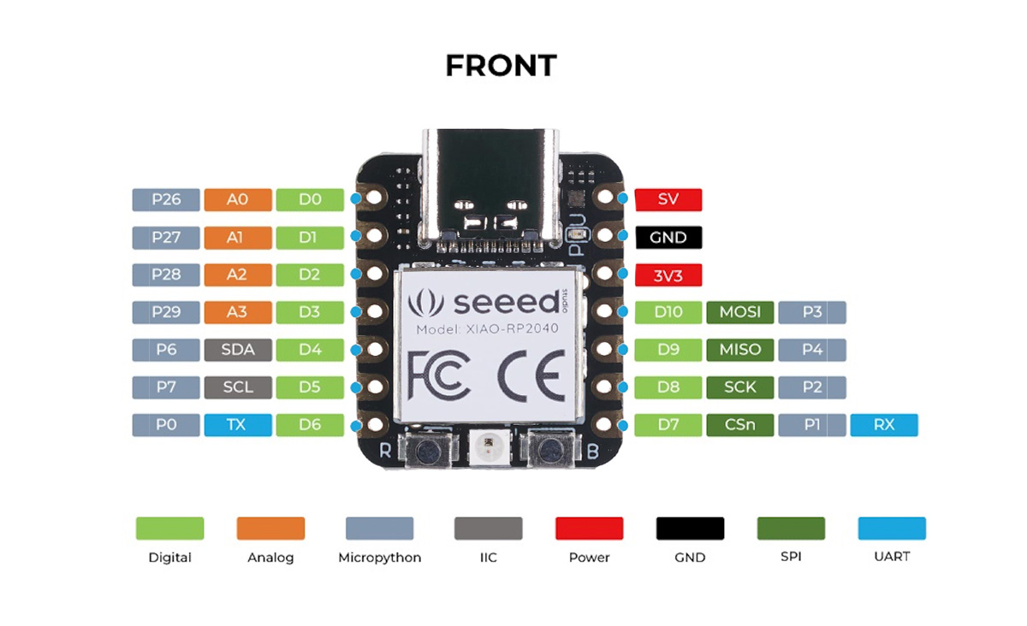PCB Layout:

Figure : Microcontroller Layout

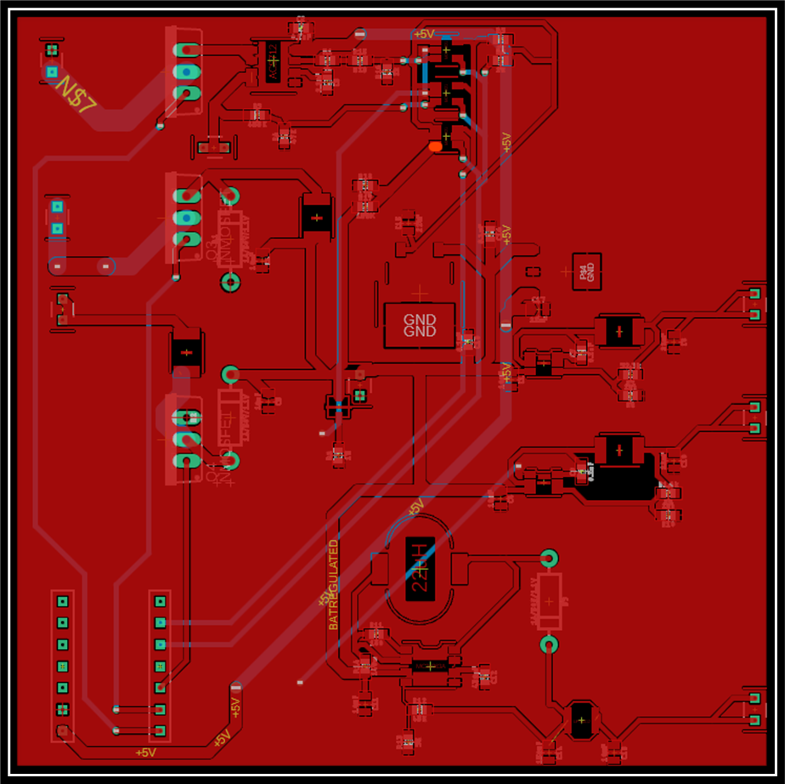 The main PCB will have a size of 90mm x 90mm. This will ensure that it can fit in the standard shape of a CubeSat. Bracket holes for mounting are planned to be placed in the corners and on the sides as needed and applicable. Path widths for the board are planned to be in the ranges of 0.508mm for datelines such as the I2C line for the analog to digital ICs. While power lines are planned to be 1-2mm depending on where they are located or how much current they are anticipated to pass. Values for these paths were calculated using a path width calculator provided from DigiKey. 2oz/sqft copper will be used for the traces to ensure that traces do not get too hot while in use. The PCB will only be 2 layers so as to avoid any complications with internal layers. The PCB will only have two layer those being the top and bottom layer. The top layer will also act as a ground plane.

Figure : Main Board Layout

Fusion Model:

The current Fusion 360 models for can be seen in the figures below. Fabrication for these models will be done in-house at the space science center for the first few prototypes using RO4003C samples from the Rogers Corp. Looking at the current design the FETS will be laying down so that they can better manage their heat dissipation. Space has been left so this can be done, but the model does need to be updated. Other similar changes will need to be made. Current plan is to have final PCBs manufactured at PCBWay. Will have two board one being the battery board and the other being the main EPS board will all subsections of the design. The main reason for doing this is space requirements with the batteries being as large as they are putting them onto the same board as the main sections would be impractical. This also gives the advantage of being able to distribute weight and heat over two boards though will also limit space aboard the CubeSats.

Figure : EPS Main Board

Figure : Battery Board

Schedule/Current Status:

Project Schedule so far has required some changes. First change is that the final day for initial research for the project was pushed to late October from early October where it was originally this has also mandated that the amount of design revision that can be completed before the winter break has been reduced from three to two. The main reason for the delay is there being questions that needed paths for potential options for voltage regulators needed to be researched before a final path could be finalized. Another change is that BoM creation was added to the timeline.

Figure : Gannt Chart

Overall time that has been spent on this project is 91 hours so far. Total time estimated for the semester was around 120 hours for the whole semester. This number was estimated with the assumption that 8 hours would be spent on the project every week. Assuming 8 hours are spent on the project for the following weeks left in the semester then a total of 115 hours would have been spent on the project this semester. This would put the total time spent slightly behind estimates for the semester.

The status of the project has it in the middle of its second design. Finishing this design will be the major focus for the rest of the semester. Starting next semester, the major goal will be to get the PCB manufactured, populated and tested. From there weak points in the design will be identified and improved on until a final design is approached.

Budget:

The budget has been broken down into three major components. These three major cost are labor, materials, and indirect cost. For labor so far the cost is up to $5,940. This can be broken down amongst three people the projects lead engineer (Elijah Gibbs), project technical advisor (Nate Fite), and the project manager (Jeffery Kruth).



Table : Hourly Wages

From there the project materials cost are broken down into the major subsystems plus and additional cost for spare parts in case something breaks down. The major categories for materials cost are the: MPPT, Batteries, Battery Regulators, Output Regulators, Microcontroller/Supporting, and spare parts. For the most part all categories were under budget which allowed for the buying of additional spare parts. This will explain why there has been an over spending on the spare parts categories as seen in Table 3: Materials Cost. There is an additional 30 dollars that have been spent on spare parts, but we are only $2.89 dollar over budget or 1.45% overbudget. These extra spares will allow for more extensive stress testing to take place without the risk of running out of parts.

Table : Materials Cost

Indirect cost for the project cover general use office supplies, building costs, and licenses. NOTE: office supplies and building costs are estimates, actual values will vary. Licenses cover software that would need to be paid for in a professional setting such as a Fusion 360 license.



Table : Indirect Costs

Bibliography:

Barsukov, Yevgen. “Battery Cell Balancing: What to Balance and How - Texas Instruments India.” *Texas Instruments*, Texas Instruments, www.ti.com/download/trng/docs/seminar/Topic%202%20-%20Battery%20Cell%20Balancing%20-%20What%20to%20Balance%20and%20How.pdf. Accessed 12 Nov. 2023.

“Basics of Ideal Diodes.” *Texas Instruments*, 2022, www.ti.com/lit/an/slvae57b/slvae57b.pdf?ts=1697616969293&ref_url=https%253A%252F%252Fwww.google.com%252F.

“Buck-Boost Converter - Circuit Diagram, Working & Applications.” *Electronics Mind*, 22 Sept. 2022, www.electronicsmind.com/buck-boost-converter/.

“Buck-Boost Converter.” *Definition of Buck-Boost Converter | Analog Devices*, www.analog.com/en/design-center/glossary/buck-boost.html. Accessed 12 Nov. 2023.

“Buck-Boost Converter: What Is It? .” *Electrical4U*, 25 July 2021, www.electrical4u.com/buck-boost-converter/.

Castaldo, Adam. “Switching Regulator Fundamentals (Rev. C).” *Texas Instruments*, www.ti.com/lit/an/snva559c/snva559c.pdf?ts=1698005745001. Accessed 13 Nov. 2023.

“Designing a Simple Over-Voltage Protection Circuit Using Zener Diodes.” *Components101*, May 2020, components101.com/articles/designing-an-overvoltage-protection-circuit-using-zener-diodes.

“Free Electronic Samples.” *Instructables*, Instructables, 8 Nov. 2017, www.instructables.com/Free_Electronic_Samples/.

“Getting Samples.” *Ladyadanet Blog RSS*, 2011, www.ladyada.net/library/procure/samples.html.

Guo, Liping, and Andrew W. Otieno. “Experiment 4: Maximum Power Point Tracking (MPPT) for Photovoltaic Systems.” *Virtual Renewable Energy Laboratory*, NIU, May 2022, renewablelab.niu.edu/experiments/MaximumPowerPointTracking.

“How to Balance Lithium Batteries in Parallel.” *Cell Saviors*, cellsaviors.com/blog/balance-lithium-batteries-parallel. Accessed 12 Nov. 2023.

Karim. “The Ideal Diode: ΜF.” *μF | Electronics & Radio*, 17 June 2021, www.microfarad.de/blog/the-ideal-diode/.

“Over-Voltage Protection for Power Supplies.” *Electronics Notes*, www.electronics-notes.com/articles/analogue_circuits/power-supply-electronics/over-voltage-protection.php. Accessed 12 Nov. 2023.

“Overvoltage Protection in Automotive Systems.” *Analog Devices*, Analog Devices, 18 Nov. 2022, www.analog.com/en/design-notes/overvoltage-protection-in-automotive-systems.html.

Podder, Amit Kumer, and Naruttam Kumar Roy. “MPPT Methods for Solar PV Systems: A Critical ... - Wiley Online Library.” *The Institutiuon of Engineering and Technology*, IET, 2 May 2019, ietresearch.onlinelibrary.wiley.com/doi/abs/10.1049/iet-rpg.2018.5946.

“What Is a Switching Regulator?” *ABLIC Inc.*, www.ablic.com/en/semicon/products/power-management-ic/switching-regulator/intro-2/. Accessed 12 Nov. 2023.

**PDR Format Acquired From:**

“Preliminary Design Review (PDR).” *Arxterra*, Arxterra, [www.arxterra.com/preliminary-design-review-outline/](http://www.arxterra.com/preliminary-design-review-outline/). Accessed 13 Nov. 2023.